FACE open house
Friday, August 21, 2015
4-6 PM

Meet the teachers, administration and behavior team!

pick up your supply list
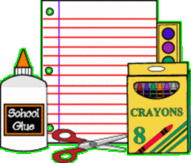 sign up for the lunch program
This is a great opportunity to meet your child’s teacher and see the classroom. This is an
opportunity to find out the teacher’s expectations and ask questions. Please come and meet
the FACE team, see the classrooms and check out the campus!
Pick up and/or drop off paperwork or just complete it here.
We look forward to seeing you between 4 and 6 PM on Friday, August 21st!

